電通二乙微處理器實驗 實驗結報

實驗名稱 | 期中考:簡易+-*/運算
組別 |  | 組員 | 俞秉謙

- 實驗目的
透過4x4鍵盤做出簡單+-*/運算
- 實驗步驟
照著上次接出硬體後打程式並輸入
- 程式碼
#include <Keypad.h>
#include "SevSeg.h"
SevSeg sevseg;
char key, key1, key2;
int x = 0;
const byte ROWS = 4;
const byte COLS = 4;
char keys[ROWS][COLS] = {
{'F', 'E', 'D', 'C'}, {'B', '3', '6', '9'},
{'A', '2', '5', '8'}, {'0', '1', '4', '7'}
};
byte rowPins[ROWS] = {5, 4, 3, 2};
byte colPins[COLS] = {10, 9, 8, 7};
Keypad keypad =
Keypad( makeKeymap(keys), rowPins,
colPins, ROWS, COLS );
void setup() {
Serial.begin(9600);
}
void loop() {
for (;;)
{
key = keypad.getKey();
if (key != NO_KEY)
{
if (key >= '1' && key <= '9')
{
Serial.print("The first number is:");
Serial.println(key);
break;
}
}
}
for (;;)
{
key1 = keypad.getKey();
if (key1 != NO_KEY) {
if (key1 >= '1' && key1 <= '9') {
Serial.print("The second number is:");
Serial.println(key1);
break;
}
}
}
for (;;)
{
key2 = keypad.getKey();
x = 0;
if (key2 != NO_KEY)
{
if (key2 == 'A')
{
Serial.print("The operation is:");
Serial.println("+");
x = (key - '0') + (key1 - '0');
Serial.print("The result is:");
Serial.println(x);
break;
}
if (key2 == 'B')
{
Serial.print("The operation is:");
Serial.println("-");
x = (key - '0') - (key1 - '0');
Serial.print("The result is:");
Serial.println(x);
break;
}
if (key2 == 'C')
{
Serial.print("The operation is:");
Serial.println("*");
x = (key - '0') * (key1 - '0');
Serial.print("The result is:");
Serial.println(x);
break;
}
if (key2 == 'D')
{
Serial.print("The operation is:");
Serial.println("/");
x = (key - '0') / (key1 - '0');
Serial.print("The result is:");
Serial.println(x);
break;
}
}
}
}
- 實驗結果及分析
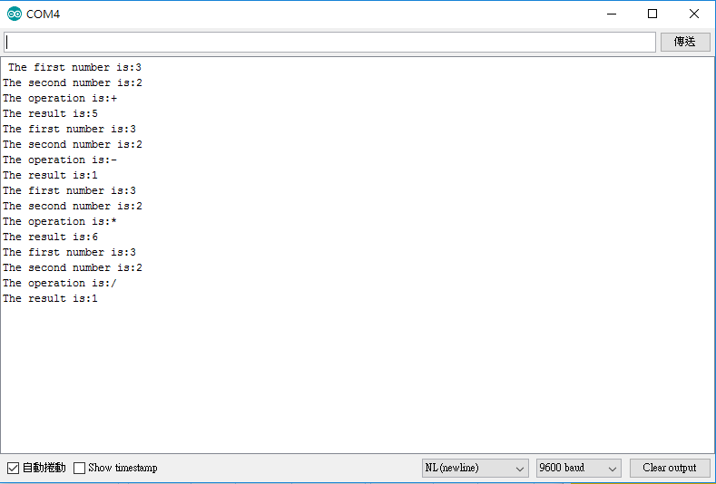
可以透過4x4鍵盤做出簡單計算機
- 心得討論
考試最難的就是不能求助於人，所以當有未提的時候只能自己不斷找問題，最後發現自己有些城市觀念不是很熟悉所以卡了不考時間。
- 電路圖
